­­­

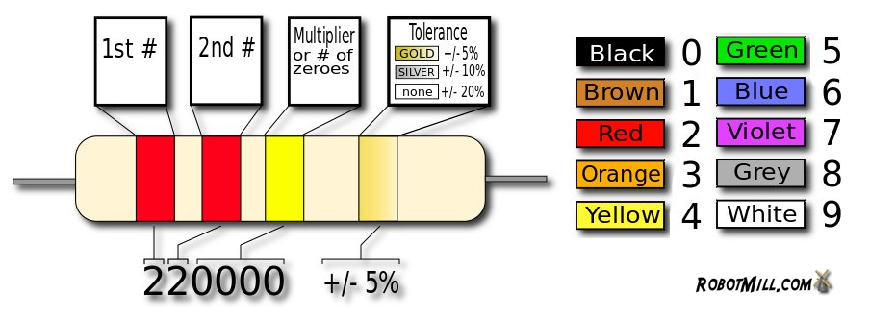

**Through-hole Soldering Tips:**

* …..

**Safety Information:  
…**

**Components List:**

1x Printed Circuit Board (PCB)

1x 74HC4017 Decade Counter 16-pin Integrated Circuit (IC)

1x NE555 Timer 8-pin Integrated Circuit (IC)

2x BC557 PNP Bipolar Junction Transistor (BJT)

3x BC547 NPN Bipolar Junction Transistor (BJT)

1x 22nF Ceramic Capacitor (labelled 223)

1x 470nF Ceramic Capacitor (labelled 474)

1x 1kΩ Resistor

7x 10kΩ Resistor

1x 330kΩ Resistor

2x 4.7MΩ Resistor

7x Light Emitting Diode (LED)

1x CR2032 Lithium 3.0V Battery

1x 20mm Surface Mount Battery Clip

Please ensure your soldering kit includes all the listed components. Do not start soldering until indicated by the lab demonstrators and carefully listen to all their instructions and advice.

Please read the safety information below and the useful placement and soldering tips.

BLUESAT Dice Kit

**­Placement Tips:**

* Component orientation must be correct:
  + Integrated Circuit orientation is  
    indicated by a notch on one end.
  + Bipolar Junction Transistor and Light Emitting Diode orientation is indicated by a flat edge.
  + Resistors and Ceramic Capacitors can be placed in either direction.
* Do not confuse the BC557 PNP transistors and the BC547 NPN transistors; they are not the same.
* Take care reading the resistor colour chart. Ask if you are confused, this is where the most mistakes are made!
* Place the smallest components first, this will make it easier to solder.
* Do not insert the battery until you are finished soldering.





Mitchell Wenke 2012